Name Period
FACS7- Final Review Packet Date

Directions: In the blanks provided, identify each piece of equipment shown below. Then briefly explain how each item of equipment is used.
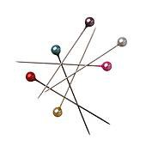
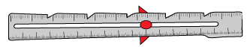
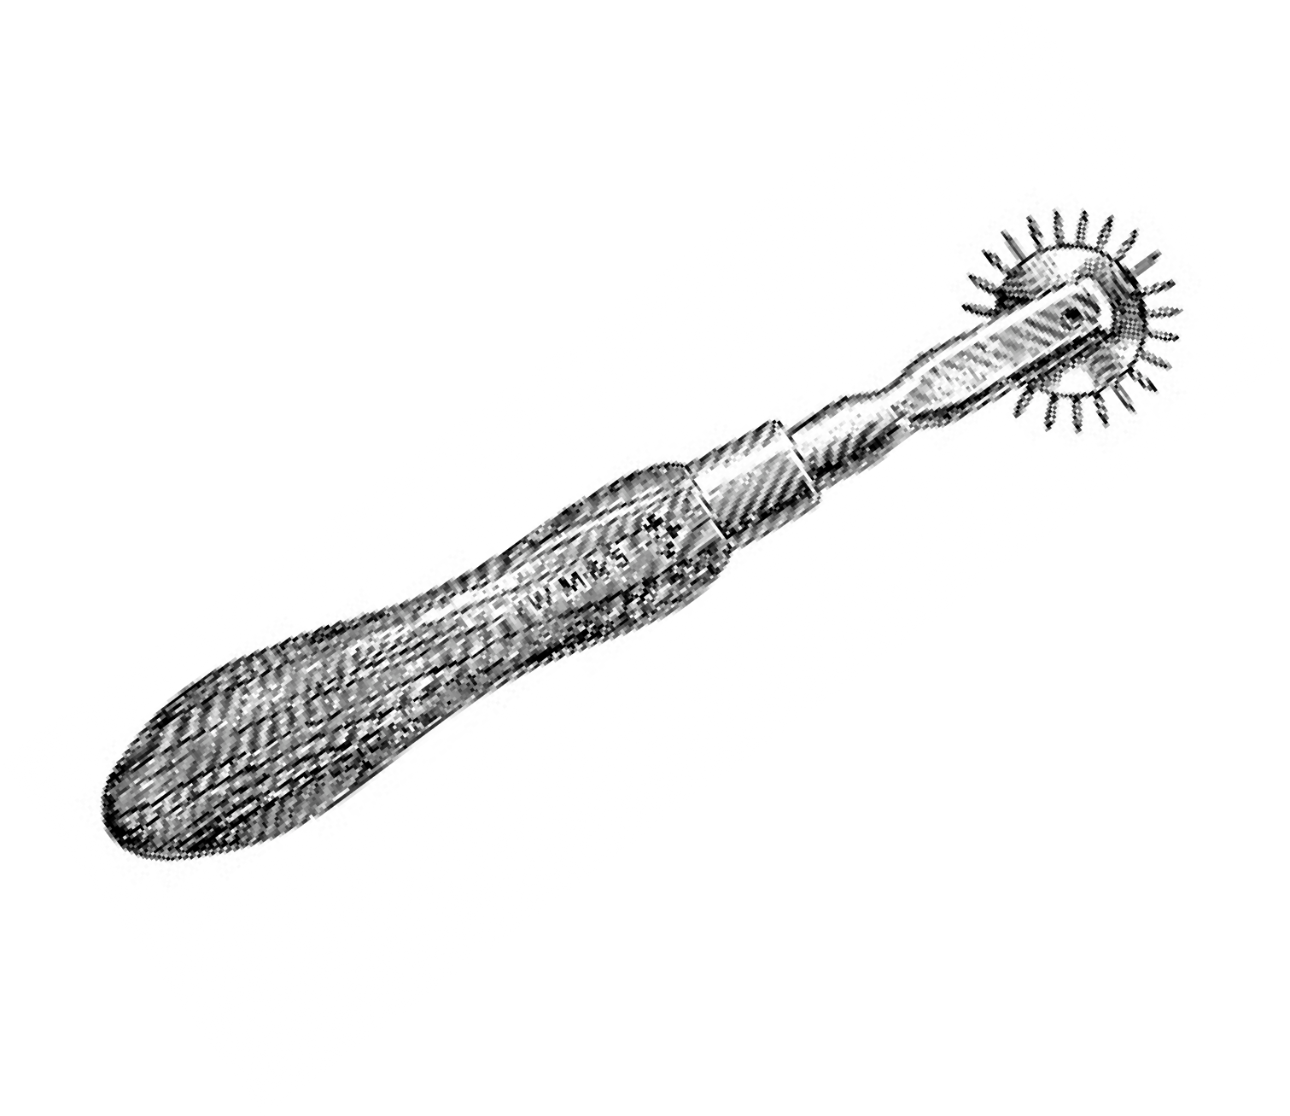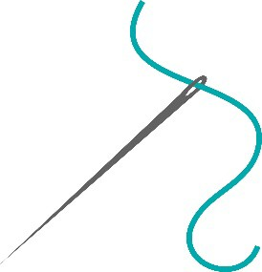1. 2.
3.
6.

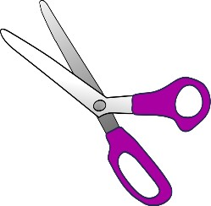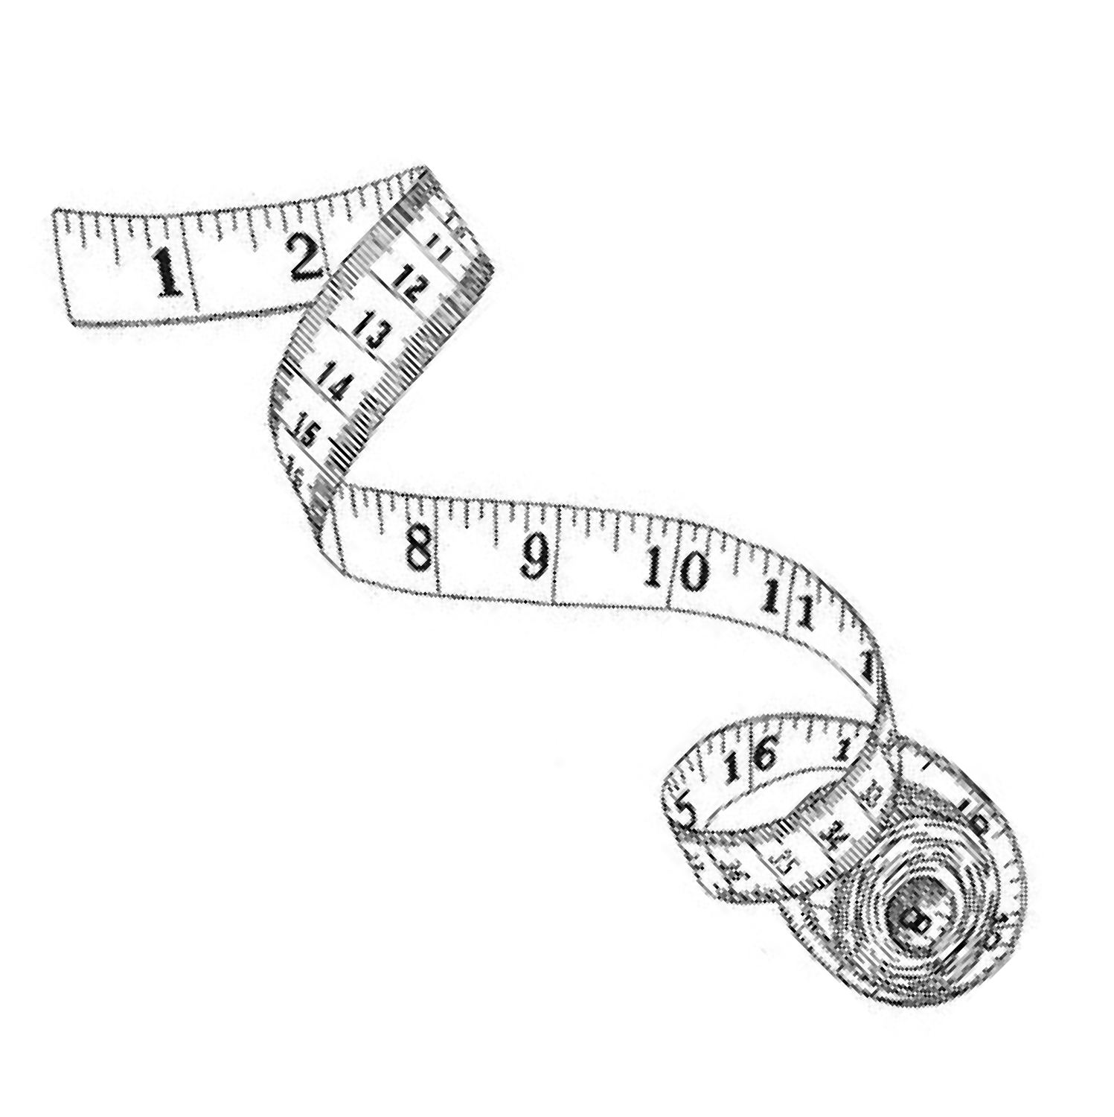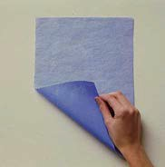4.
5.
9.

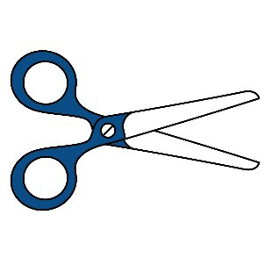
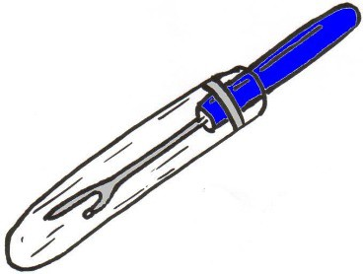8. 10.
7.

c.
Name of Tool | Definition
1. Straight Pins | used to hold two pieces of fabric together & patterns to fabri
2. Sewing Guage | 6 inch long ruler, used to measure small amounts.
3. Tracing Wheel | makes temporary marks on fabric, used with tracing paper.
4. Marking Pencil | makes temporary marks on fabric.
5. Shears | used for cutting fabric and thread.
6. Hand Sewing Needle | used for hand sewing.
7. Seam Ripper | removes sewing mistakes.
8. Tape Measure | 60 inches long, used for taking body measurements
9. Tracing Paper | makes temporary makrs on fabric, used with tracing wheel.
10. Scissors | used for cutting paper.

Directions: Match the part of the sewing machine with the correct function.

- L
Needle plate

- CFeed dog teeth

- D Presser foot
  - Makes stiches longer or shorter.

  - Holds the spool of thread in place.

  - Small teeth that move fabric to needle as you sew.

M
Reverse button

- Holds the fabric in place as you sew.

- B Spool pin and cap

- NTension Control

- F Presser foot lever
- ETake-up lever
- Moves up and down guiding the upper thread to the needle.

- Raises and lowers the presser foot.

- Keeps the thread where it needs to be to prevent tangles.

- Holds the needle in place.

- Controls how wide a stitch is.

K
- J
- I
Foot pedal Hand wheel
Stitch Width

- Used to manually raise and lower the needle.

- Controls the speed of the needle.

- Marked with guides for sewing straight seams.
- Allows the machine to stitch backwards.

12._A Stitch Length

- Controls the tightness or looseness of the upper thread.

O

Stitch Selection
- Selects the stitch you want to use.

G
Thread Guide

- H
Needle Clamp

Directions: Below are five sewing construction techniques. The steps are not listed in the correct order. Put the steps in the proper order by placing the step number in the blank- using “1” for the first step, “2” for the second step, and so on.

Sewing A Seam
- 5 Finish raw edges, if needed.
- 3 Put right sides of fabric together; match notches; pin.
- 2 Sew on scrap to check tension of the machine.
- 4 Stitch in correct direction; secure stitching at the beginning and end.
- 1 Thread the machine.
Directions: Answer the following questions:
  - A standard seam allowance is 5/_8 .
  - When you make a seam, place r_ig h_t sides together.
  - Which direction should pins go when pinning two pieces of fabric together?
pe_r_p en_d i_c_u l_a_r_
  - Where and Why do we backstitch? a_t th e__b_e g_i_n n_i_n_g an_d__a t_t_h e e_n d
of a se_m . It i_s t_o_ s_e c_u r_e _th e_ s_t_i_t_c_h .
  - Which way do we turn the hand wheel? t_o_w ar_d_s yo_u
  - Sewing Kit Comes with what two important pieces of information? pa_t_t_e_r_n an_d d_i_re c_t_i_o_n s

Directions: Examine the pattern pieces below. Identify each of the numbered symbols by writing in the correct term in the space provided.
1. gr_a_i_n li_n e
2. n_o t_c_h
- c_u_t_t_in g__l_in e
- sti_t_c_h_i_n g li_n_e
- pla c_e on f_o_l_d l_in e
- d_o t
- no_t_c_h

do_t
- s_e_a m _a_l_lo wa_n c_e
- s_t_i_t_c_h i_n_g_ l_in e

Cooking Terms

Knead | Beat | Cube | Mince | Baste
Boil | Cream | Dice | Fry | Chop
Directions: Use the word bank above to define the cooking terms below.

- cu_b e To cut food into half inch pieces.
- _c_r_e am To blend butter/margarine with sugars.
- di_c_e_ To cut food into quarter inch pieces.
- mi_n_c e To cut food into pieces as small as possible.
- bo_i_l_ To heat a liquid till rapid bubbles occur.
- c_h op To cut food into small irregular pieces.
- f_r_y To cook in hot oil.
- b_a ste To moisten meat with melted fats or liquids.
- kn_e ad To mix by folding and pressing dough.
- b_e at_ To mix quickly.

Directions: Answer the following questions

- Describe the method for measuring flour using standard dry measuring cups.
s_p o_o n in t_o__t_h e_ d_r_y m eas_u r_in g _c_u p__a nd l_e v_e l o_f_f w i_th a_ m et_a_l s_p at_u_l_a ._

- Describe the correct way to measure brown sugar.
pac_k i_n t_o t_h e dr_y mea_s ur_in g cup and l_e v_e l_o f_f__w it_h a meta l__s_p atu l_a_.
_

Equipment is No Puzzle

Directions: Find the words listed below in the word search puzzle. Circle the words in the puzzle. Then write each word in the appropriate column below to indicate whether it is a utensil, small appliance, or large appliance.

Freezer | Refrigerator | Range | Broiler
Oven | Sifter | Mixing Bowls | Wire Whisks
Knives | Shears | Colander | Strainer
Spatula | Ladle | Saucepan | Cake Pan
Mixer | Toaster | Blender | Microwave

R R O T A R E G I R F E R S S R B E E M K M E U V E C R R P S U E R T D D G N S L N A J A A E H L X O F N F N E I I D D W T K S E U I I
I A U T E A V U A U O I E A Z M L S L C Z R L Y E L L U R F R C E E G O C T L T B A S G F R C S U G R U C S D V N R E T S A O T I N L Y S A U C E P A N N N J L G I M X O W H I S K S R E G P B I X W I R E F K I M W A V E V A B I S L W O B H R I K V O S V N N M Z R Q A Q L

Utensils | Small Appliances | Large Appliances
knives colander | mixer | freezer
spatula saucepan | toaster | oven
sifter whisk | blender | refrigerator
shears strainer | broiler | range
ladle cake pan | microwave
mixing bowl

Equipment Match

Directions: Match each description in the left-hand column with the correct term from the right hand column. Write the letter of the term in the space provided. Do not use any term more than once. Some terms will not be used.

Descriptions Terms
H1. Used to remove peel from fruits and vegetables. A. Chef’s Knife

D 2. You can rub cheese or vegetables on its rough surface to shred them. B. Colander
A 3. Used to cut vegetables. C. Food Processor

O4. Especially good utensil for beating egg white mixtures and stirring sauces. D. Grater

K 5. Has wide, flexible blade. E. Hand Mixer
E 6. Appliance used for making cake batter and mashing potatoes. F. Kitchen Shears
N 7. Grasping instrument used to remove ears of corn from hot water. G. Ladle
L 8. Used to level off dry ingredients in measuring cups. H. Paring Knife
I 9. Used to mix shortening and flour for biscuits. I. Pastry Blender

B10. Bowl with large holes and mounted on a base or on small legs. J. Rotary Beater
- Rubber Scraper
- Spatula

- Strainer

- Tongs

- Wire Whisk

Directions: Identify the kitchen equipment and explain how the utensil is used when cooking.

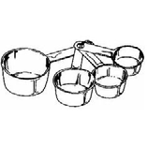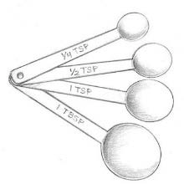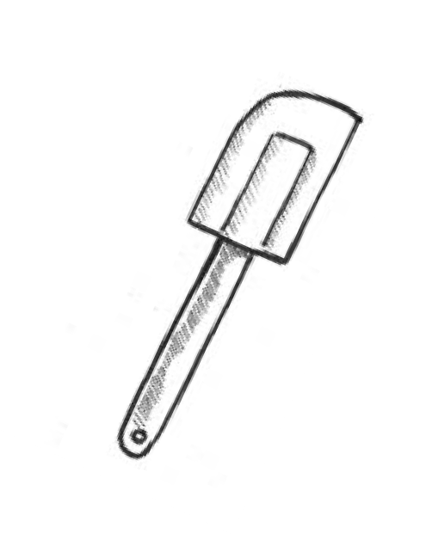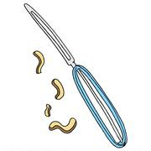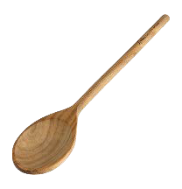Name of Utensil How is the utensil used in cooking?

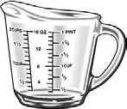 | Liquid Measuring Cup | used to measure liquid ingredients.
 | Dry Measuring Cups | used to measure dry ingredients.
 | Measuring Spoons | used to measure smaller amounts of liquid and dry ingredients.
 | Rubber Scraper | used to scrape sides of bowl clean.
 | Peeler | used to remove skins from fruits and vegetables.
 | Wooden Spoon | used to stir ingredients together.
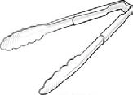 | Tongs | used to pick up and turn foods over.
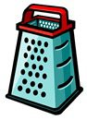 | Grater | used to shred or grate foods.

Check Yourself: The Parts of a Recipe

  - Most reicpes have these main parts. Draw a line from each part to its meaning.

    - Directions

(B)
      - the number of servings the recipe makes.

    - ingredients (D)
- the steps you follow to make the recipe.

    - yield
(A)
- what the recipe is called

    - name (C) d. the different foods you put together.

  - Read the recipe on the right. Follow the directions below and answer the questions.
    - Think up a name for the recipe. Write it on the line in the recipe.
Name of recipe:

(Makes 4 or 5 servings)
3-pound chicken, cut into pieces
½ cup flour Pinch of pepper
¼ teaspoon sage
¼ teaspoon salt
1P.ut the flour, salt, sage, and pepper into a paper bag.2Shake the bag to mix the ingredients.3Place the chicken
pieces (only two at a time) into the bag. 4Shake the bag so that the chicken is coated with the flour mixture.5Place
the chicken peeces in a baking pan. H6eat the oven to 325°. 7Bake the chicken 45 minutes.8Then baste the chicken with its juices.9Bake for 15
minutes.
    - Draw a circle around the yield. How many people can you serve?
_4 _- 5_
    - Put a √ in front of each ingredient. Which ingredient must you prepare before you do the steps?
The__c h_i_c_k en_.
    - Number the steps in the order that you would do them. How many steps altogether are in the directions?
9_ s_t_e ps_._

Vegetable Noodle Soup

- lb. dry noodles 10 oz. box of frozen mixed vegetables
- qt. cold water 2 c. chopped potatoes
1 tsp. salt 6 oz. can of kernel corn
¾ c. chopped onion 8-oz. can of tomatoes
½ c. chopped celery 1 pt. hot chicken stock
1 T oil pinch of pepper

Here are the ingredients for vegetable noodle soup. Read them carefully. How much of each ingredient do you need? Put an X next to the right amount.

- Dry noodles 5. Chopped onion 9. Can of tomoates
_ 1 tablespoon _ ¾ kilogram _ 8 ounces
_ 1 pound _ ¾ cup _ 8 grams
_ 1 liter _ ¾ can _ 8 quarts
- Cold water 6. Oil 10. Chicken stock
_ 2 cups _ 1 teaspoon _ 1 ounce
_ 2 kilograms _ 1 tablespoon 1 pot
_ 2 quarts _ 1 taste _ 1 pint
- Salt 7. Chopped potatoes 11. pepper
_ 1 teaspoon _ 2 cartons _ a pinch
_ 1 tablespoon _ 2 pounds _ a gross
_ 1 millimeter _ 2 cups _ a pound
- Chopped celery 8. Frozen mixed vegetables 12. Kernel corn
_ ½ can _ 10 ounces _ 6 cans
_ ½ cup _ 10 pounds _ 6 cups
_ ½ carton _ 10 grams _ 6 ounces

Following Directions

In order for a recipe to turn out right, you must understand its directions. Read the recipe below. Look closely at its directions. Then answer the questions.
Mini Cheesecakes
I ng r e d ie nt s :
1/3 cup graham cracker crumbs 1/4 cup white sugar
1 tablespoon white sugar 1 1/2 teaspoons lemon juice
1 tablespoon margarine, melted 1/2 teaspoon grated lemon zest 1 (8 ounce) package cream cheese, softened 1/4 teaspoon vanilla extract
1 egg
D ir e c t io ns :
Preheat oven to 325 degrees Fahrenheit. Grease a 6 cup muffin pan. In a medium bowl, mix together the graham cracker crumbs, sugar and margarine with a fork until combined. Measure a rounded tablespoon of the mixture into the bottom of each muffin cup, pressing firmly. Bake in the pre-heated oven for 5 minutes, then remove to cool. Keep the oven on. Beat together the cream cheese, sugar, lemon juice, lemon zest and vanilla until fluffy. Mix in the egg. Pour the cream cheese mixture into the muffin cups, filling each until 3/4 full. Bake at 325 degrees Fahrenheit for 25 minutes. Cool completely in pan before removing. Refrigerate until ready to serve.

What coking terms are used in the recipe? Write the cooking term and then write the correct definition. (Example:
Simmer means to cook very slowly.)
Words Meanings

_p r_e he_a t_ to_ war_m t_h e__o v_e n _u_p_ ah_e ad of__ti_m e_._
mi_x t_o com bine_ in gr_e_d i_e_n t_s t_o ge_t_h e_r_._

b_a ke _t_o co_o k _s_o met_h_i_n g__i_n a_n_ o_v en_.

bea_t _a_n _o_v er__a_n d und_e r__m o_t_i_o_n us_i_ng__a _w h_i_s k__o r h_a nd mix e_r._

gr_e_a s_e_ t_o pu_t a soli_d f_a t__o_n_ a pan t_o p_r_e ve_n t s_t_i_c_k ing.

c_o o_l_ t_o__l_e t_f_o od get_t_o w ar_m _t_e_m pe_r_a t_ur_e_._

What cooking equipment do you need to for this recipe? _d_r_y_ m eas_u r_in g_ c_u ps_, met_a_l s_p at_u_l_a ,_g r_a t_e_r_,
c_u s_t_a r_d cup_s , m ea_s ur_in g spo_o ns_,__m i_x in g b_o wl_,_w o_o de_n_ s_p oo_n ,__f_o_r_k ,__m uf_fi_n p_a n,_h an_d mi_x e_r_,__c o_o l_in g ra_cks

Check Yourself: Cooking Equipment
Raw Apple Cake
4 cups apples, peeled and diced
¾ teaspoon cinnamon
2 cups sugar
2 eggs
2 cups flour
1 ½ sticks butter, melted
1 ½ teaspoons baking soda
2 teaspoons vanilla
1 teaspoon salt
1 c nuts
In a large bowl, mix the apples and sugar. In another bowl, sift together the flour, baking soda, salt and cinnamon. Combine the flour mixture and the apple mixture. Add the eggs, melted butter, vanilla and nuts. Mix well with a wooden spoon. Pour the batter into two 8-inch round cake pans. Bake at 350 degrees for 45 minutes.
Yield: 2- 8 inch round layers
Directions: Answer the questions about the recipe.

- What utensils would you need to prepare the apples? k_n if_e ,__c_u t_t_in g boa_rd, pe_e_l_e r
- What utensil would you need to measure the flour, sugar, and nuts? dr_y mea_s ur_in g cup_s a_n d_ m et_a_l__s_p at_u_l_a
- Which measuring spoons would you use to measure each of these ingredients?
3- 1/4 t or

Baking soda 1_t an_d _1 /2_ t
Cinnamon _1 /_4_t an_d_ 1/2 t _ Salt 1 t
Vanilla 2-__1_t _

- What equipment would you need to melt the butter: a bowl or a saucepan?
bow l_ _

- What utensil would you need to mix the dry ingredients: a sifter or a wire whisk? sif_t_e r
- What equipment would you need to mix the ingredients in? How many would you need?
on_e _w oo_d en__s po_o n_ _
- What equipment would you need to bake the batter in? How many would you need?
2 8-_i_n_c h__r_o un_d_ c_a ke pan_s _

Changing the Yield of a Recipe

Directions: In the left-hand column, give the correct measurement for each ingredient if you were only making half the recipe. In the right-hand column, give the correct measurement of each ingredient for a doubled recipe. Then answer the questions at the bottom of the page.

Peach Cobbler

Half Measurement | Recipe | Double Measurement
3/4 c | 1 ½ C flour | 3 c
1 1/2 t | 3 tsp. baking powder | 6 t or 2T
1/4 t | ½ tsp. salt | 1 t
1/8 t | ¼ tsp. baking soda | 1/2 t
1/8 c | 1/3 c butter | 2/3 c
1/2 c | 1 c chopped pecans | 2 c
1 | 2 eggs | 4
1/4 c and 1/8 c or 1/3 c | ¾ c milk | 1 1/2 c
2 - 3 | 4 -5 fresh peaches, sliced and sweetened | 8 - 10
1/2 c | 1 c sour cream | 2 c
1/4 c | ½ c brown sugar | 1 c

Equivalents and Substitutions

Directions: In Section I, write the correct abbreviation for each measurement in the space provided. In Section II, write the equivalent of each amount in the space provided.

Sections I: Abbreviations

Teaspoon _t_o_r t_s_p_.__ Tablespoon _T o_r tb s_p. Cup c_

Ounce o_z Pint p_t

Sections II: Equivalents
Pound lb . Quart q_t_.
Gallon g_a_l

Draw the gallon man below to help with some the equivalents.

3 teaspoons = 1 tablespoon | 1_6_ tablespoons = 1 cup | 4 tablespoons = ½ stick of butter
4 tablespoons = ¼ cup | 2 cups = 1 pint | 1_/_2_ cup = 4 ounces
12 tablespoons = ¾ cup | 1 gallon = 4 quarts | 4 cup = 1 quart
2 pints = 1 quart | 8 tablespoons = ½ cup | 8 tablespoons = ½ cup

Food and Kitchen Safety
Label the thermometer using the definitions in the box to the right.
212 B 1.
140
C
2.
40

32
D
3.
0 A 4.
°F
A. Freezing temperatures- bacteria is sleeping but is still alive.
B. Boiling temperature- destroyed.
most
bacteria is
- Danger Zone- bacteria multiples rapidly.

- Refrigerator temperature- bacteria grows at a slow rate.

Food Safety and Sanitation: Using the word bank below, choose the correct vocabulary word that matches the definition.
Sanitation Bacteria Cross Contamination Danger Zone Food Borne Illness

  - f_o o_d bo_r_n e__il_l_n_e s_s - sickness caused from eating contaminated food; sometimes called food poisoning.
  - d_a n_g e_r z_o n_e - the range of temperatures at which most bacteria multiply rapidly between 40° - 140°.
  - b_a c_t_e_r_i_a - living organisms that can only be seen with a microscope.

  - c_r_o_ss c_on_t_a_mina_t_ion
- when bacteria is spread from one food to another.

  - s_a n_i_t_a_t_io n_ - keeping an area clean and free from harmful bacteria.

Substitution Situations

You are making chocolate chip cookies at home but…

- You don’t have dry measuring cups. But you do have all the measuring spoons. How can you measure
¼ cup of shortening? u_s e t_h e 1 ta ble s_o on f_o u_r t_i_m es_.

- You don’t have a 1-teaspoon measuring spoon. But you have all the other spoons. How can you measure 1 ½ teaspoons of baking powder? u_s e 1/_2 a ta ble po_o n or a 1/_2 t_e_a sp_o o_n t_h_r_ee t_i_m es_.

- You don’t have a 1- tablespoon measuring spoon. But you have all the other measuring spoons. How can you measure 1 tablespoon of cinnamon? us_e t_h e 1 t_e_a s_p oo_n th r_e e t_i_m es_.

- Finish these sentences. Use the words listed below.
Less Pack Sift Level Past Two
  - You p_a c_k brown sugar by pressing it into the measuring cup.
  - Sometimes you s_i_f_t flour before you measure it.
  - You use a straight utensil to l_e v_e l off dry ingredients.
  - When you measure sugar, you fill the cup pas_t the top.
  - To get 2/3 cup of brown sugar, you would measure 1/3 cup tw o times.
  - 1 cup of sifted flour is le s_s than 1 cup of unsifted flour.
Label the following dry measuring cups.

a. 1/_4 cup b. 1/3 cup c. 1_/_2 cup d. 1 cup
Label the following measuring spoons.

a. 1 Tablespoon b. 1 teaspoon c. 1/_2 teaspoon d. 1/_4 teaspoon

